Problem C: Search for the factor

A tree is called and n-ery tree when it's branching factor is n. Branching factor is the highest amount of children that each parent in that tree can have. The height of a tree is the number of levels in which the nodes are distributed. The root node does not have any parents and the leaf nodes don't have any child. The inner nodes are either parents of other child nodes or child to other parent nodes or both at the same time. In a complete n-ery tree all the nodes except the leaf nodes have n children. All the levels of a complete n-ery tree are at their full capacity, that means, every parent has n children. The leaf nodes do not have any children at all. See the figure below where n = 3, it's a complete ternary (3-ery) tree. It's height is 4 and it has 40 nodes, including root node, inner nodes and leaf nodes.
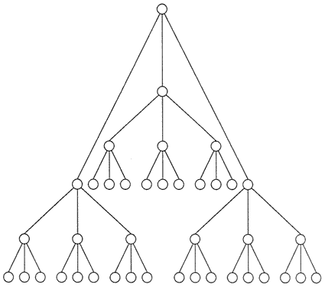
Given the number of nodes in a complete n-ery tree and it's height, can you calculate the value of n, the branching factor of that tree?
The input will contain 500 test cases. Each case will contain 2 integers, S and h on a single line. First one (S) will be the number of nodes in the tree and the second one (h) will be it's height. The data limits for the two integers are, 1<=S<9999999 and 1<=h<24. For each set of input produce one line of output expressing the value n. The difference between the correct value and output can be less than 0.00000000001 (1e-11). If a branching factor cannot be found, output “Impossible”.

Sample input | Sample output
1 1  15 4  1615420 4  4194303 1 | 1  2  117  Impossible

